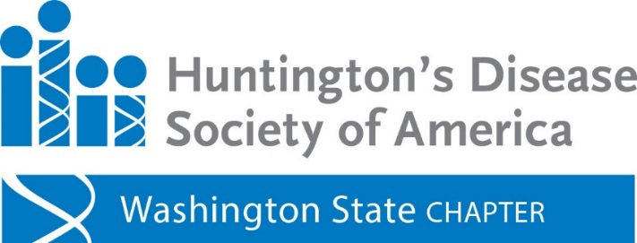

Celebration of Hope - 2nd Annual Jazz Benefit

Saturday, May 20th
7 pm (Check in begins at 6pm)
Resonance at SOMA Towers
Bellevue, WA
$50 per person
(Donor Benefit $40 Per Person)

CLICK HERE TO PURCHASE TICKETS

The evening will feature:
Buffet dinner - includes vegetarian/gluten-free options & cash bar (beer & wine)
Dessert auction & silent art auction
Jazz concert & dancing throughout the evening, with music by award winning jazz artist
Alex Dugdale and the 200 Trio

For additional information please contact Karen Cohen
(312) 550-7905 - Washington@hdsavolunteer.org
